**WEEK 6**

**Q1.**

**CODE**

#include<stdio.h>

void main()

{

int c, no;

printf("Enetr a no");

scanf("%d",&no);

switch (no>0)

{

case 1:

{

printf("%d no is positive", no);

}break;

case 0 :

{// condition ofr negative

switch (no<0)

{

case 1:

{

printf("%d is negative",no);

}break;

case 0:

{

printf("%d is zero value", no);

}break;

}

}

}

}

**OUTPUT**

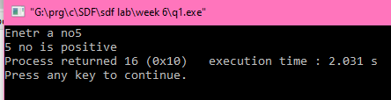

**Q2.**

**CODE**

#include<stdio.h>

void main()

{

int sum,dif,pro,q,r,a,b,c;

printf("Enter the no");

scanf("%d", &a);

printf("Enter the no");

scanf("%d", &b);

printf("1. for addition\n2. for subtraction \n3. for multiplication \n4.division \n=>");

scanf("%d",&c);

switch(c)

{

case 1:

{

sum=a+b;

printf("sum of %d and %d is %d",a,b, sum);

} break;

case 2:

{

dif=a-b;

printf("difference of %d and %d is %d",a,b, dif);

}break;

case 3:

{

pro=a*b;

printf("product of %d and %d is %d",a,b,pro);

}break;

case 4:

{

q=a/b;

r=a%b;

printf("quotient of %d divided by %d is %d",a,b,q);

printf("remainder of %d divided by %d is %d",a,b,r);

}break;

default : "Wrong choice Entered";

}

}

**OUTPUT**

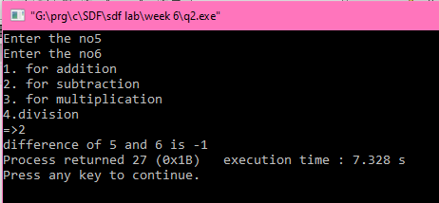

**Q3.**

**CODE**

// roots of quadric equation

#include<stdio.h>

#include<math.h>

void main()

{

int a=0,b=0,c=0;

float d=0,d1=0,d2=0;

printf("Enter the coefficient of x^2 =>");

scanf("%d",&a);

printf("Enter the coefficient of x =>");

scanf("%d",&b);

printf("Enter the constant =>");

scanf("%d",&c);

d=(b*b)-4*a*c;

switch(d>0)

{

case 1:

{

d1=((-b)+sqrt(d))/(2*a);

d2=((-b)+sqrt(d))/(2*a);

printf("THE ROOTS OF THE QUATION (%d)x^2 + (%d)x + (%d) =0 is :- \n %0.2f and %0.2f", a,b,c,d1,d2);

}break;

case 0:

{

switch(d==0)

{

case 1:

{

printf("=====THE ROOTS OF THE EQUATION ARE EQUAL ===== ");

d1=((-b)+sqrt(d))/(2*a);

d2=((-b)+sqrt(d))/(2*a);

printf("\n THE ROOTS OF THE QUATION (%d)x^2 + (%d)x + (%d) =0 is :- \n %0.2f and %0.2f", a,b,c,d1,d2);

}break;

case 0:

{

printf("THE ROOTS DO NOT EXIST");

}

}

}

}

}

**OUTPUT**

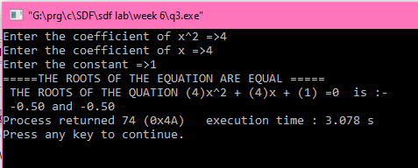

**Q4.**

**CODE**

#include<stdio.h>

void main()

{

int n;

printf("ENTER THE MONTH NUMBER => ");

scanf("%d",&n);

switch (n)

{

case 1:

printf("JANUARY");

break;

case 4:

printf("APRIL");

break;

case 5:

printf("MAY");

break;

case 6:

printf("JUNE");

break;

case 7:

printf("JULY");

break;

case 2:

printf("FEBRUARY");

break;

case 3:

printf("MARCH");

break;

case 8:

printf("AUGUST");

break;

case 9:

printf("SEPTEMBER");

break;

case 10:

printf("OCTOBER");

break;

case 11:

printf("NOVEMBER");

break;

case 12:

printf("DECEMBER");

break;

default : printf("NO SUCH MONTH EXISTS");

}

}

**OUTPUT**

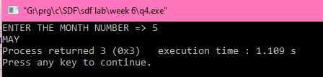

**Q5.**

**CODE**

#include<stdio.h>

void main()

{

char n;

int c;

printf("Enter the character => ");

scanf("%c",&n);

printf("1. to convert to small or to capital \n2. to print ASCII value \n3. to check for type \nEnter the choice => ");

scanf("%d",&c);

switch(c)

{

case 1:

{

// CONVERSION

if (n> 65 && n <90)

{

n=n+32;

printf("the converted value is %c", n);

}

else if (n>96 && n <123)

{

// convert to small

n-=32;

printf("the converted value is %c", n);

}

else printf("YOUVE ENTERED A SPECIAL CHARACTER SO NO CONVERSION POSSIBLE");

} break;

case 2:

{

// print ascii value

printf("the ASCII VALUE OF %c is %d", n,n);

}break;

case 3:

{ // check char

if (n> 65 && n <90)

printf("%c is a capital character", n);

else if (n>96 && n <123)

{

printf("%c is a small character", n);

}

else if (n>47 && n<58)

{

printf("%c is a digit", n);

}

else printf("YOUVE ENTERED A SPECIAL CHARACTER");

}break;

}

}

**OUTPUT**

